First website researched: https://www.chess.com/

<https://www.chess.com/>

Features:

* Allows for you to play chess against a human online with an online match up system
* Allows for users to login or sign up to create an account

Accounts can be creates by logging in with google and allow you to track your progress with tutorials puzzles and challenges

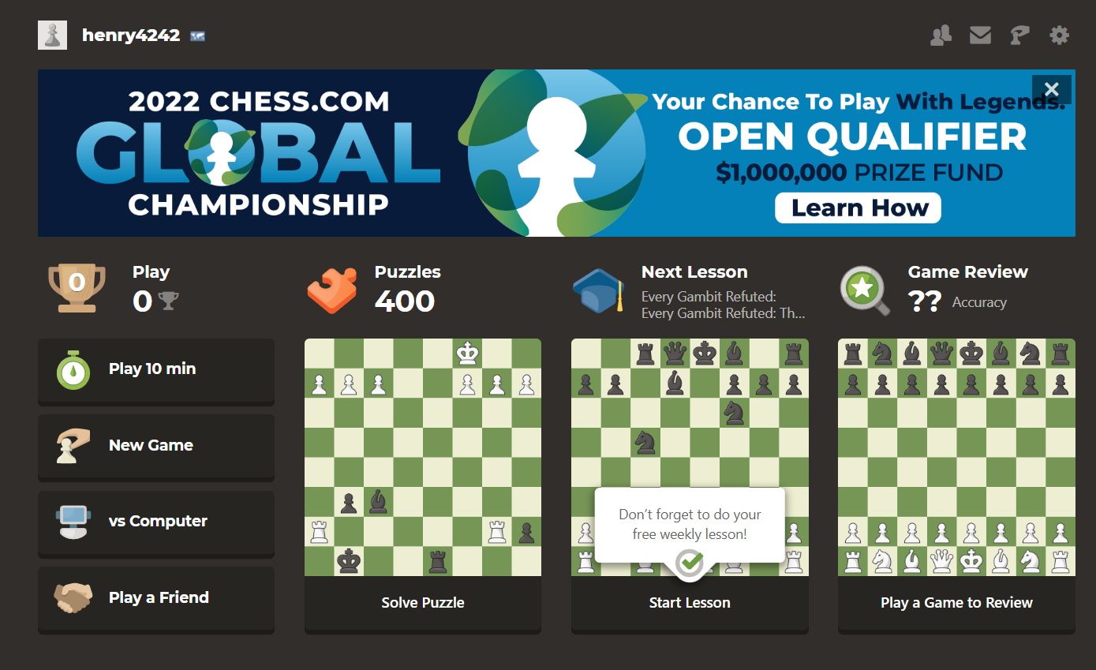

Logging in also allows users to collect features and later upgrade to the premium mode for more advances features.

I will now focus on the play vs the computer mode.

You then select the appropriate difficulty:

the board is represented by an 8\*8 coordinate grid

Clicking a piece shows the possible squares to which it can move with dots an highlights the piece you have selected

After the user moves the computer moves. The last move is shown with 2 yellow squares to highlight what piece moved and to where

For complex game states a log is provided of what moves where made and in what order (if no piece next to a square then it was a pawn that moves, the from square is also unclear)

Clicking on a move allows for you to see the board state just after this move was made

Once checkmate is reached the game ends as the chess board prevents new moves and a popup window show that the game is over. The rematch button is highlighted to attract the user’s eye. Taken pieces are shown next to the player along with name, picture and trophies.